7PAM2000-0901-2023 – APPLIED DATA SCIENCE 1

Assignment 1: VISUALISATION

BY

KAVIBHARATHI SOMASUNDARAM

Student ID: 22027052

Email: [ks23aad@herts.ac.uk](mailto:ks23aad@herts.ac.uk)

GITHUB LINK:

<https://github.com/KavibharathiSomasundaram/ASD1-Assignment-1--KAVIBHARATHI>

1. Line plot:

The below line plot describes the temperature of the months (January, February and March) over the years which is mentioned in the graph. Blue color denotes temperature in January over the years, Orange color denotes temperature in February over the years, Green color denotes temperature in March over the years. As we could see, at the starting of the year, March indicates the highest temperature and at the end of the year as well.

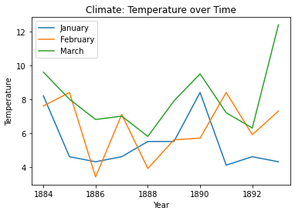

2.Pie chart:

The pie chart describes the temperature ratio during the spring season over the years which is mentioned in the graph. The distribution of the temperature is shown in the chart and it is highlighted in percentage.

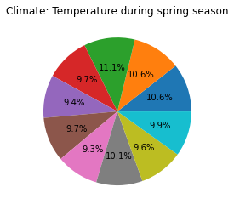

1. Bar graph:

The Bar chart describes the annual temperature over the years. The highest annual temperature recorded in 2003, 2006 and the lowest temperature recorded in 2010. Visualization and comparison of the data can be done easily using the bar chart.

